**Seesaw Directions**

**Tips:**

* You can log-in to Seesaw online (follow the directions on the Online Student Log-in Directions document OR your child’s homeroom teacher may provide a document with an individualized QR/text code)
* You can log-in to Seesaw using the app on a device. There are two different Seesaw apps:



In order to have your child complete activities or post to their journal, install this app.

Parents/Guardians – you likely have the Family app installed on their device if you have been viewing your child’s journal and reading updates from your child’s teacher.

* **See the next page for directions to log-in through the app**
* Tips for accessing the “right” class:
  + When you sign-in with your email/password (either on the computer or on the app), all the classes you are rostered to, including specials, will show up. To choose a different class,

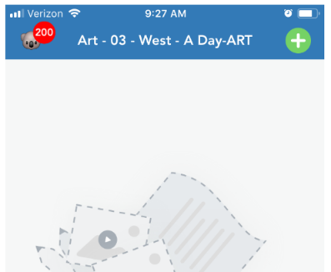click on the upper left hand corner, and your list of classes will be available.

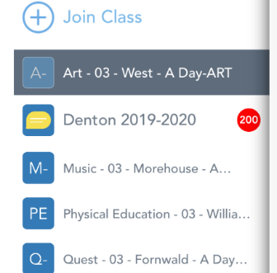

* 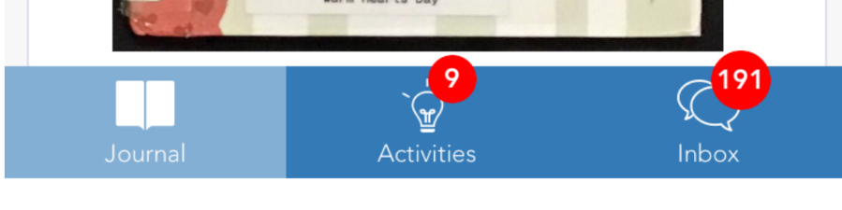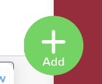If you are asked to complete an “**assignment**” in Seesaw, instead of clicking the from the main journal, click on the Activities tab.
* The **Inbox** is where teachers can post messages.
* 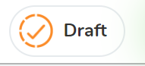**Saving a draft:** If you are working on an activity that you don’t have time to finish, you can save it as a draft by clicking on the orange check instead of the green check. Then you can go back and edit/finish your draft later.

**Directions to log-in through the app:**

1

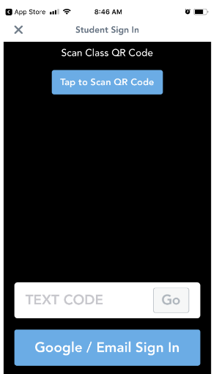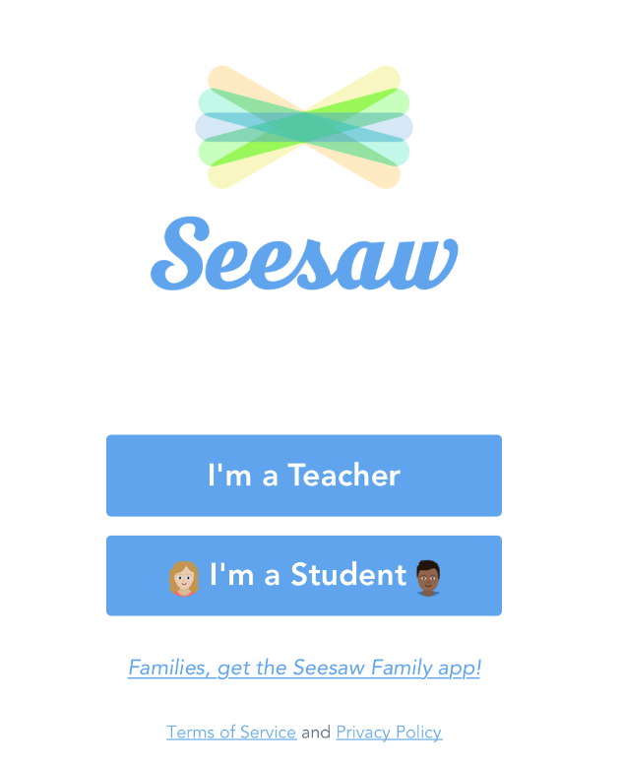

**If you don’t have a QR reader but have a text code from your teacher, use this option.**

**If you are using your email/password log-in, select this option and go to step 3.**

**If you have a QR code from your teacher, select this option.**

2

**Select “I’m a Student”**

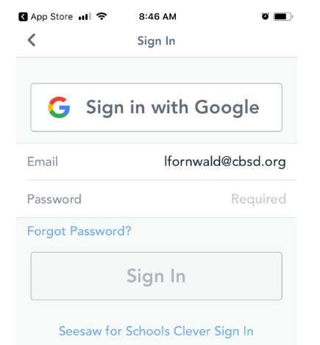

3

**Select Seesaw for Schools Clever sign-in.**

**You will be taken to another screen where you will type your** [**username@student.cbsd.org**](mailto:username@student.cbsd.org) **and your regular password.**